LECTURE NOTE FOR PRINCIPLES OF EXTRACTIVE METALLURGY /4TH SEMESTER MME
Module-IV
Process Flow Sheet: Recovery Of GOLD
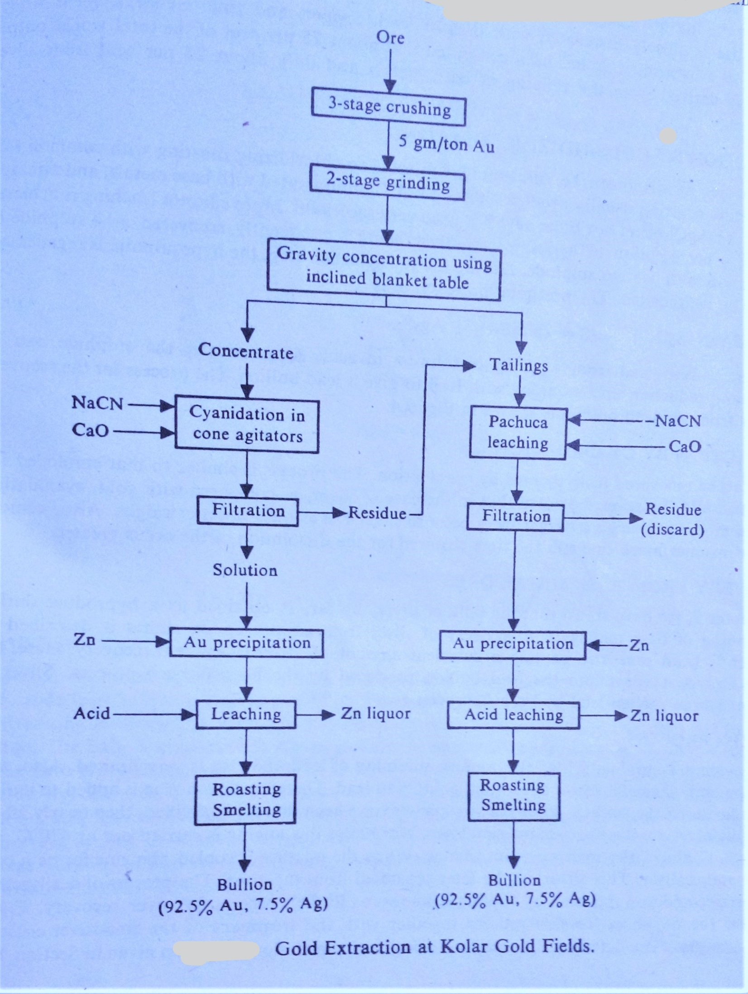
Process Flow Sheet: Recovery of NICKEL
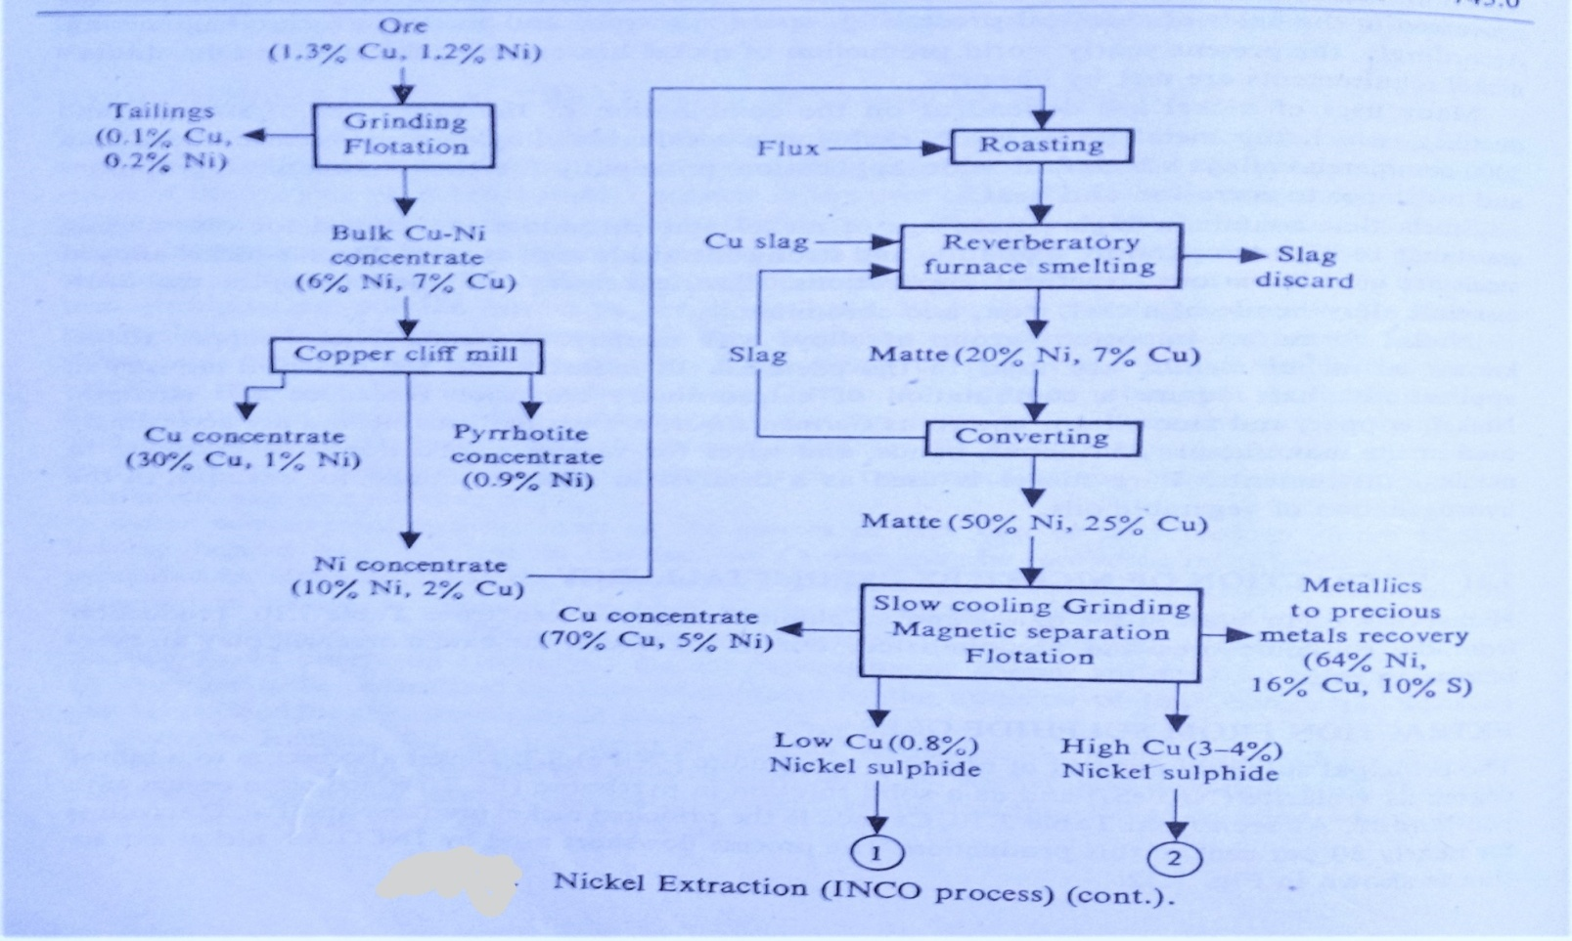
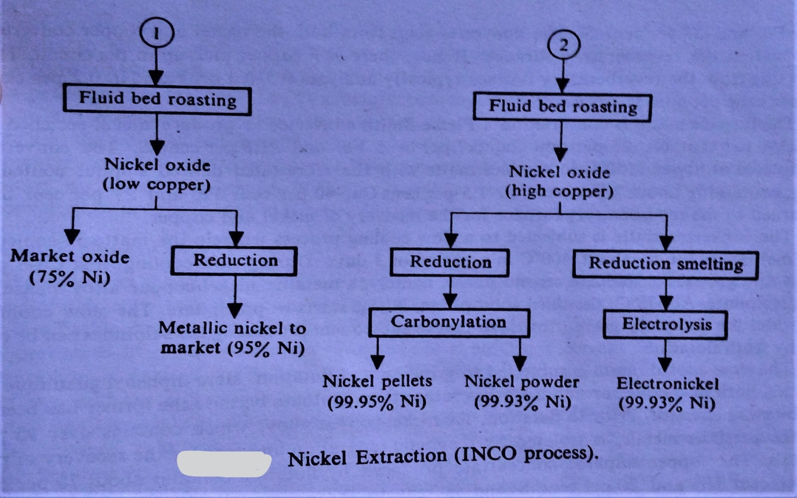

Process Flow Sheet: Recovery of COBALT
